Minimundo
Colorea e recorta os diferentes elementos para construir o teu minimundo.

Fauna

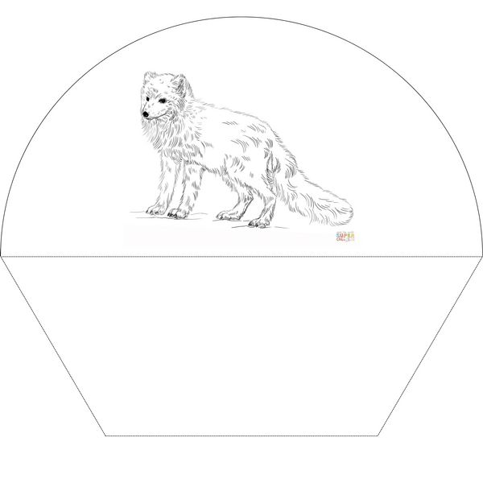
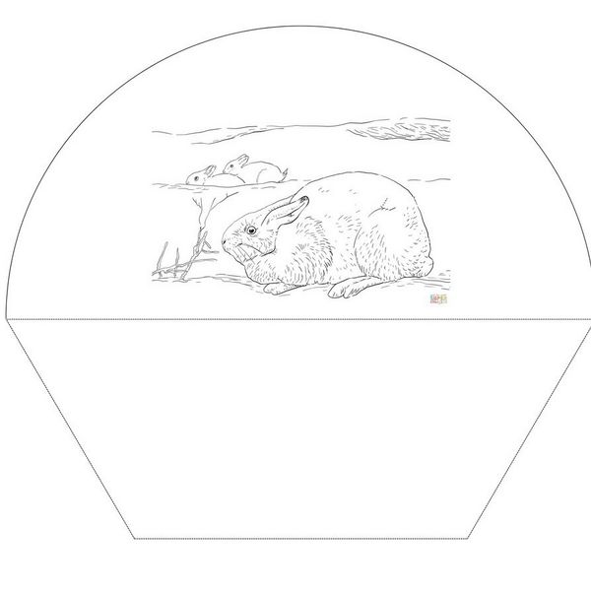

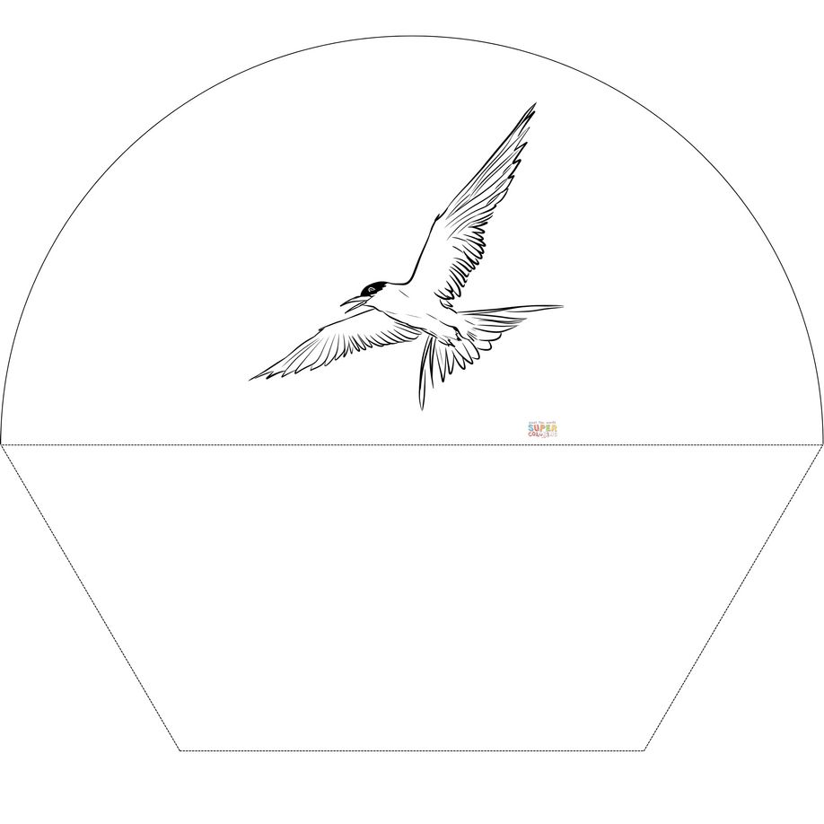
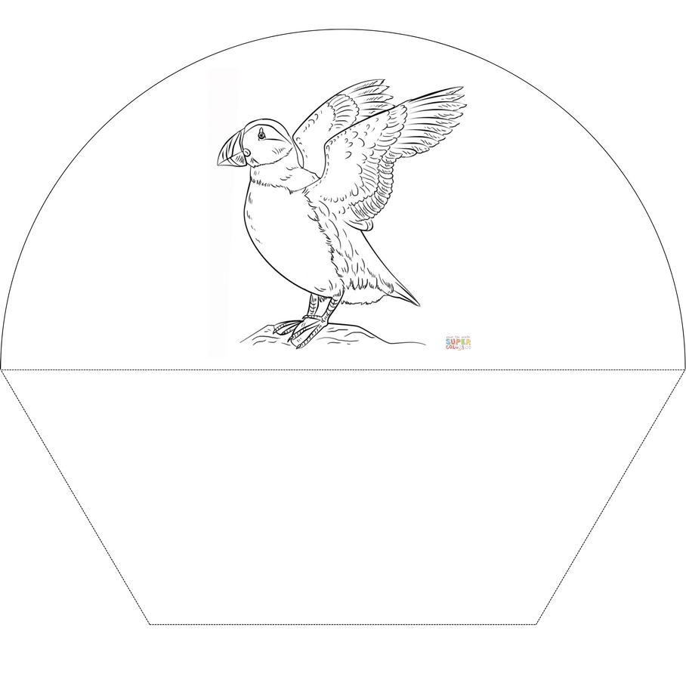

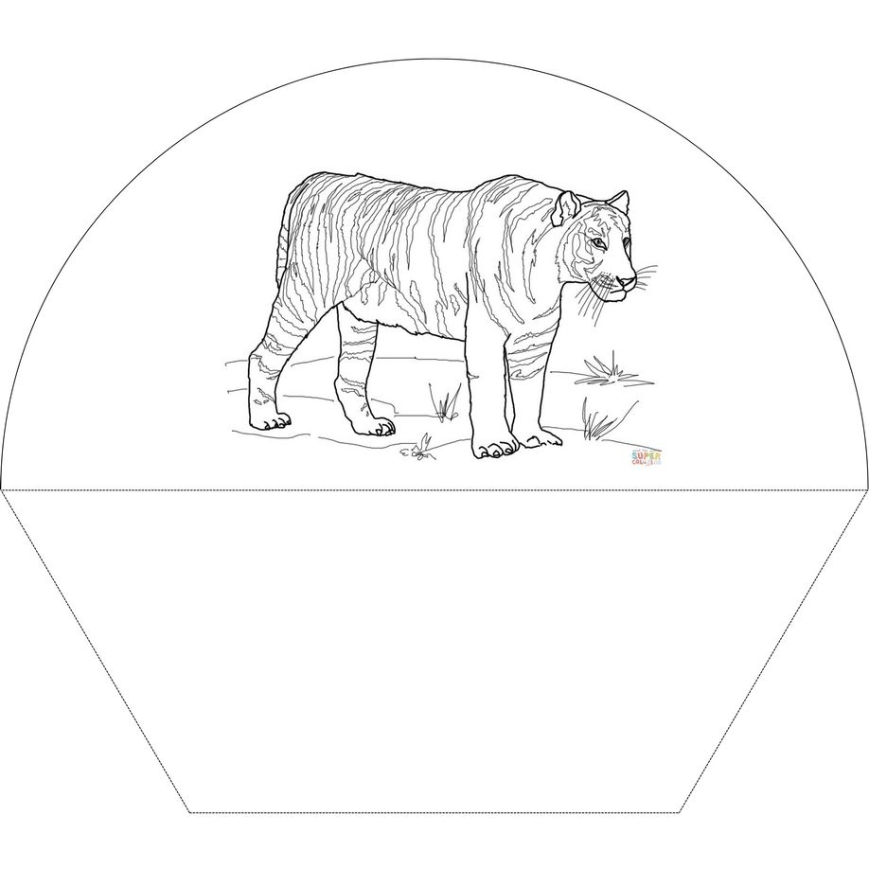
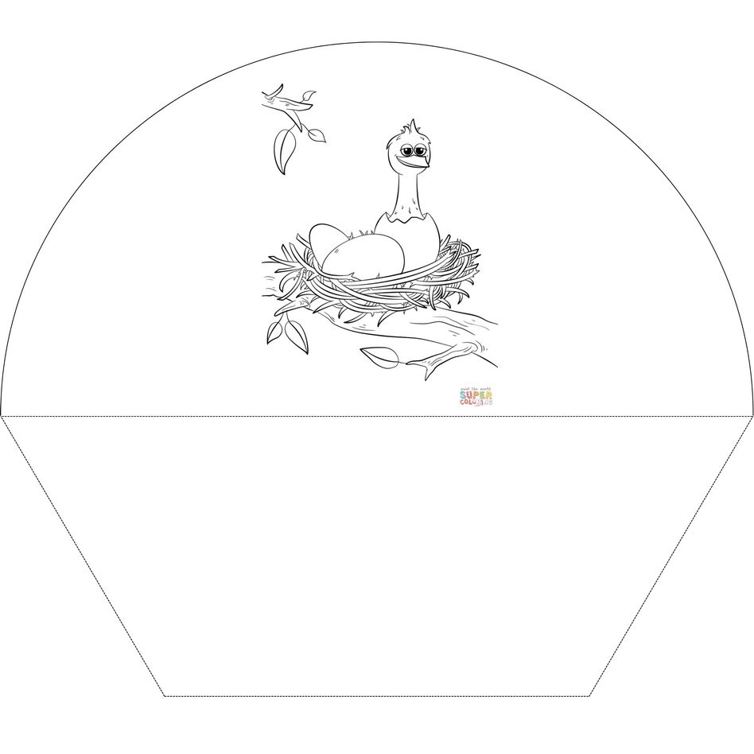
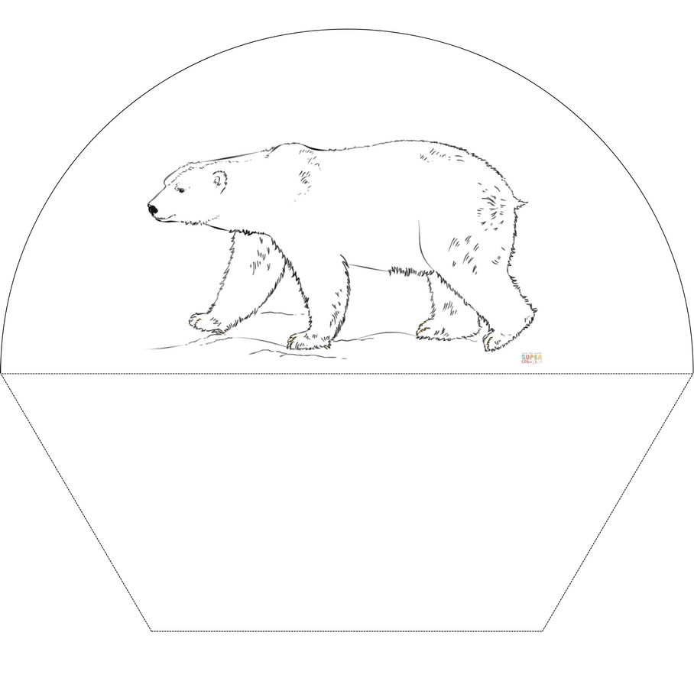
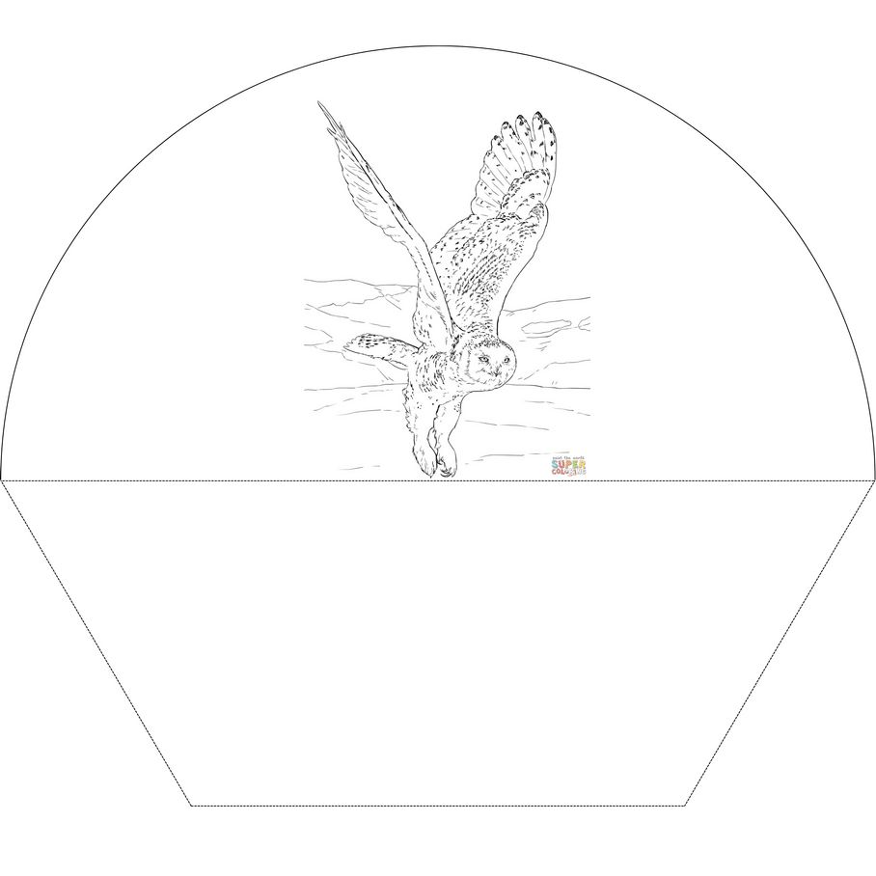
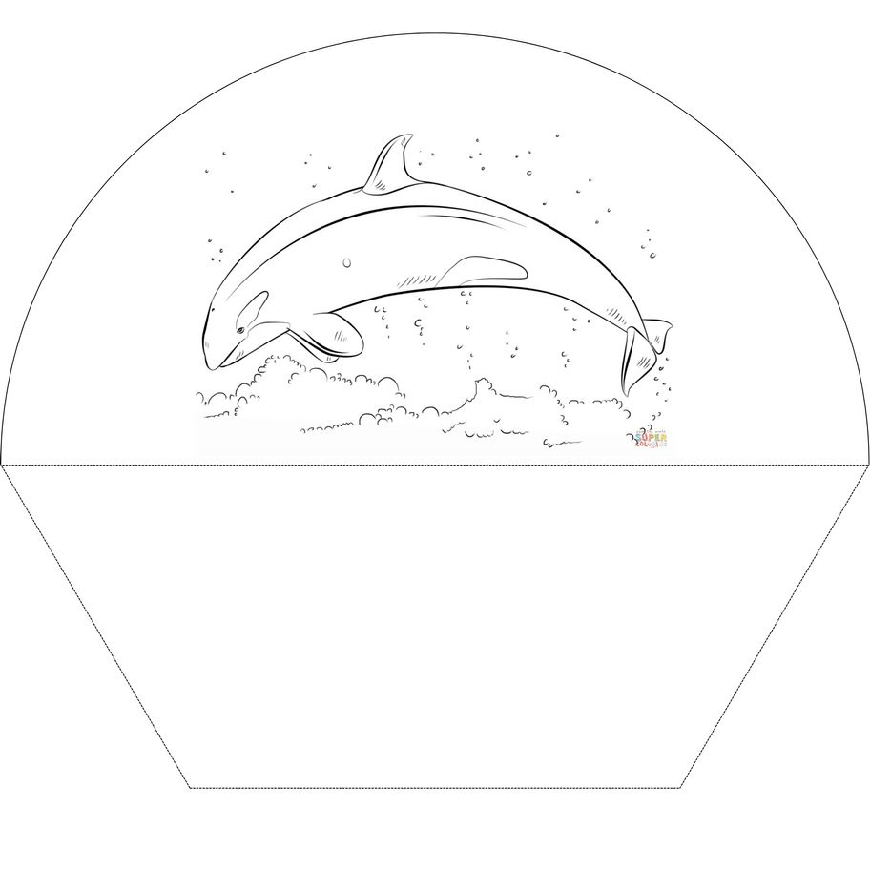
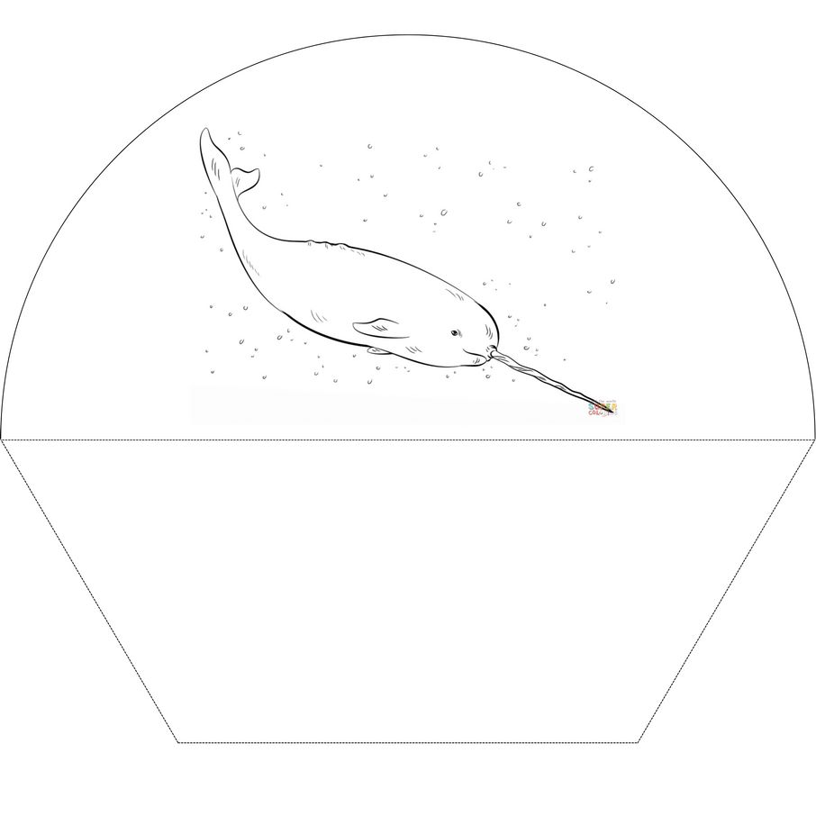
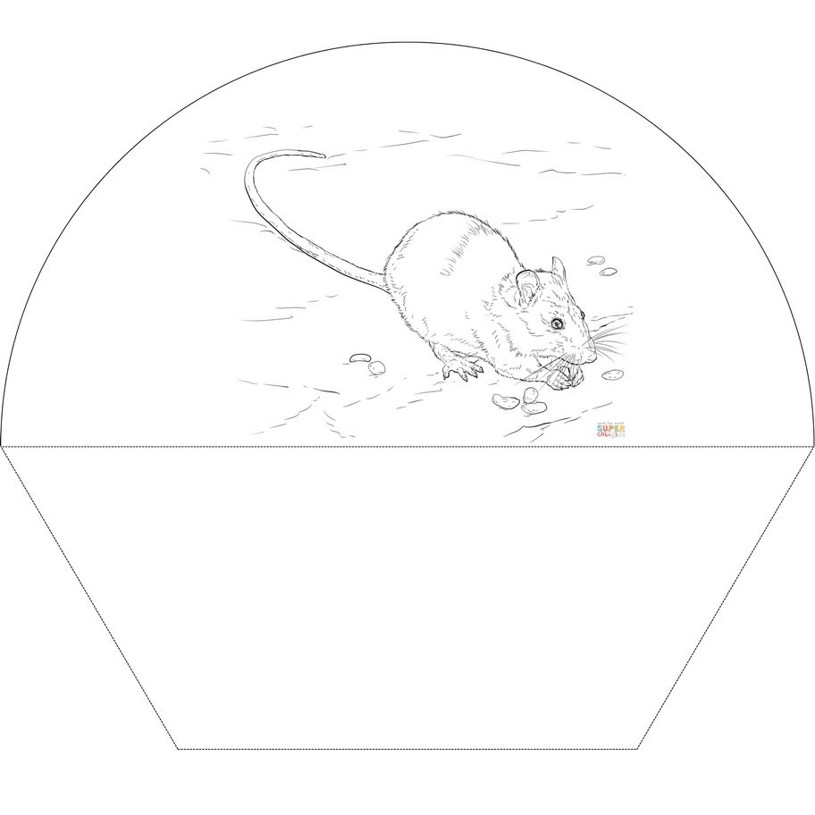
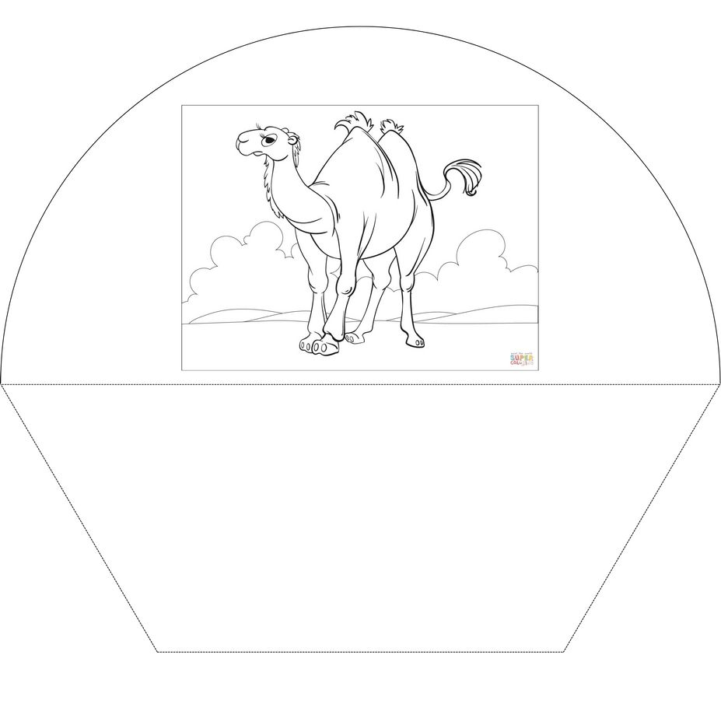
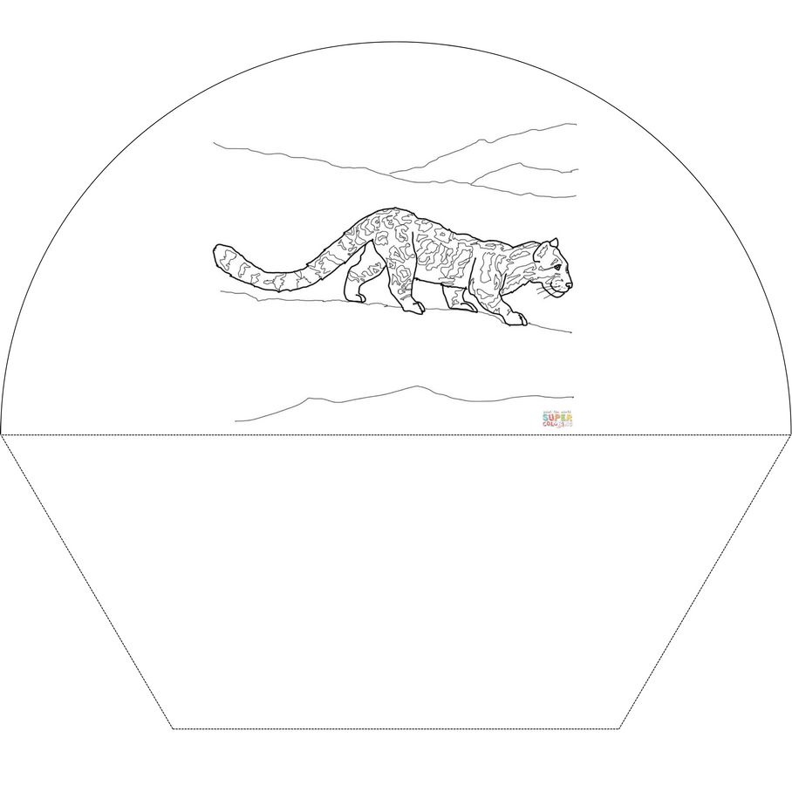
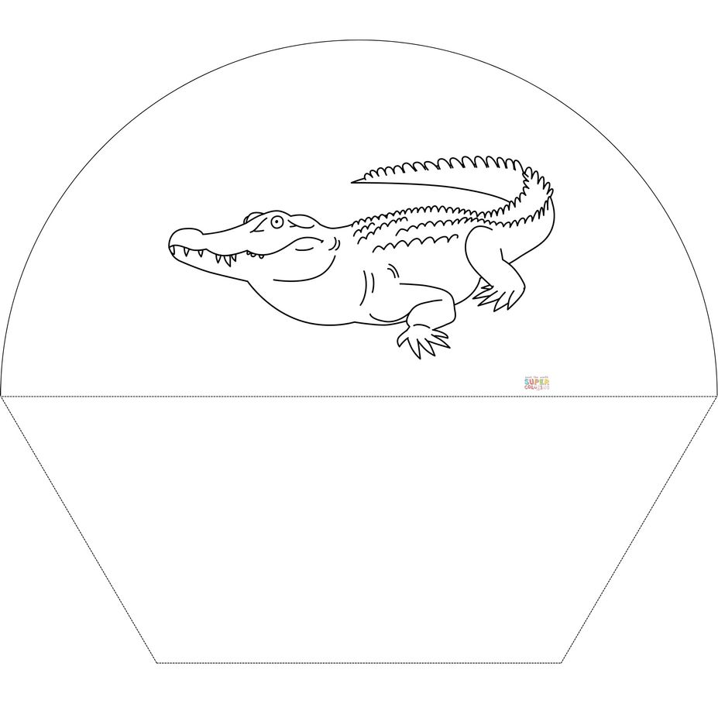
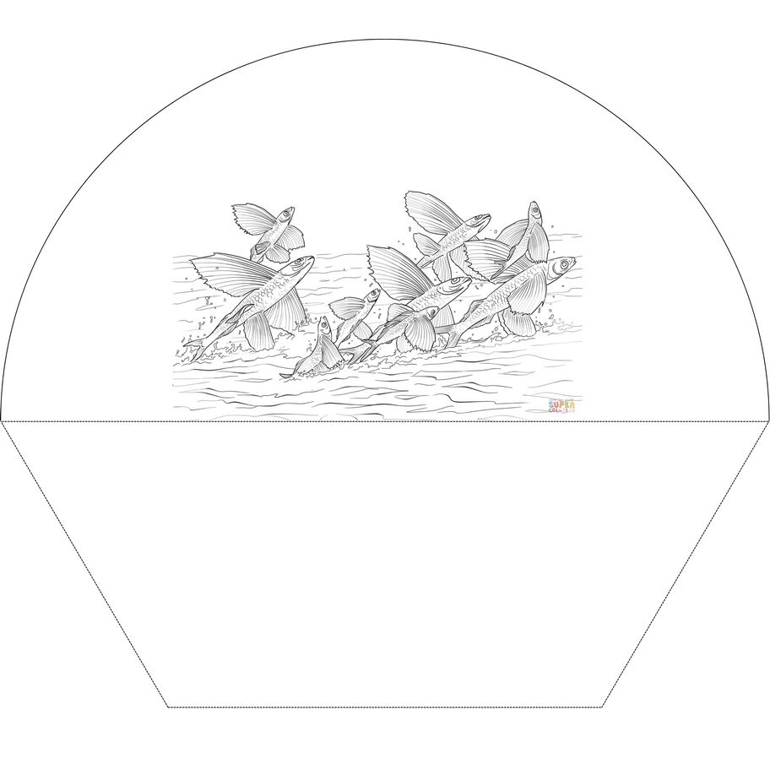
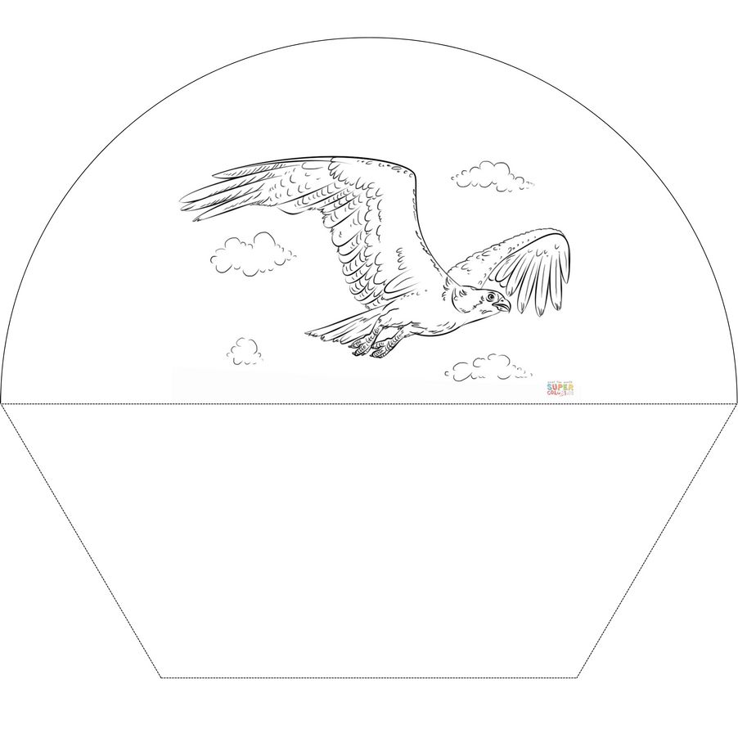
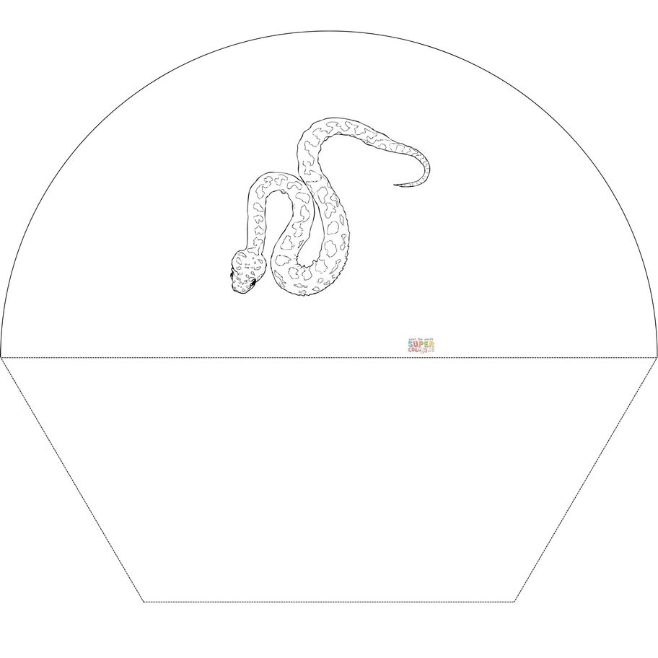
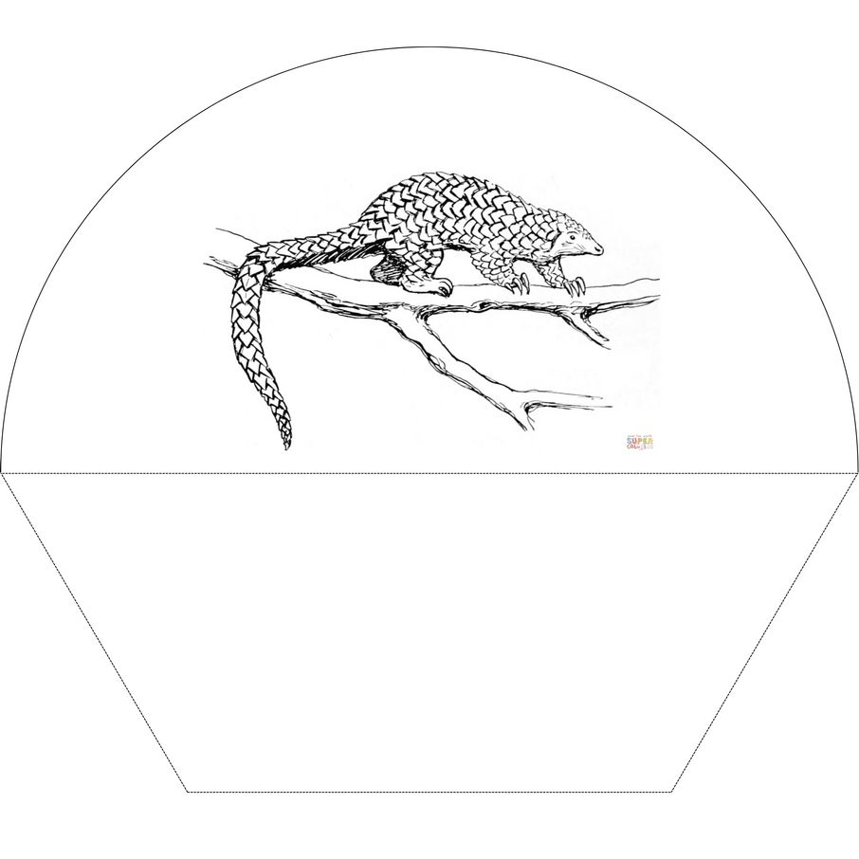
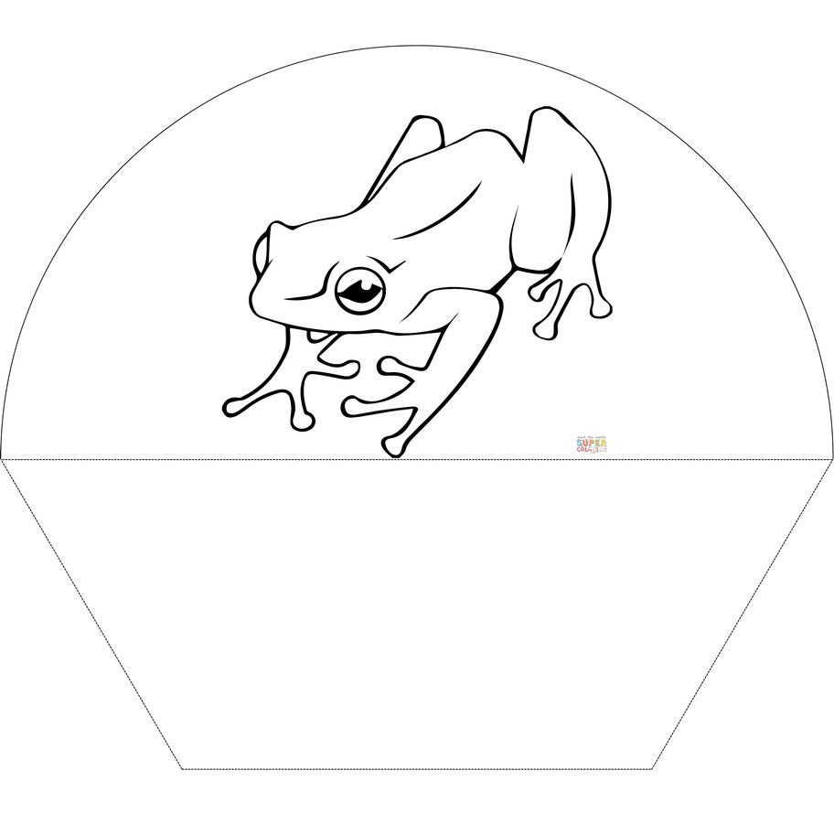
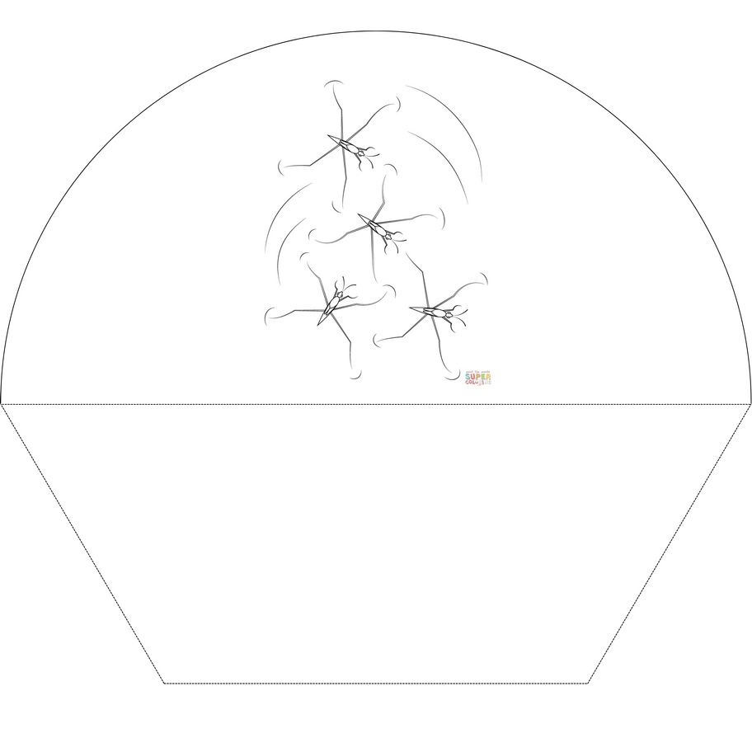
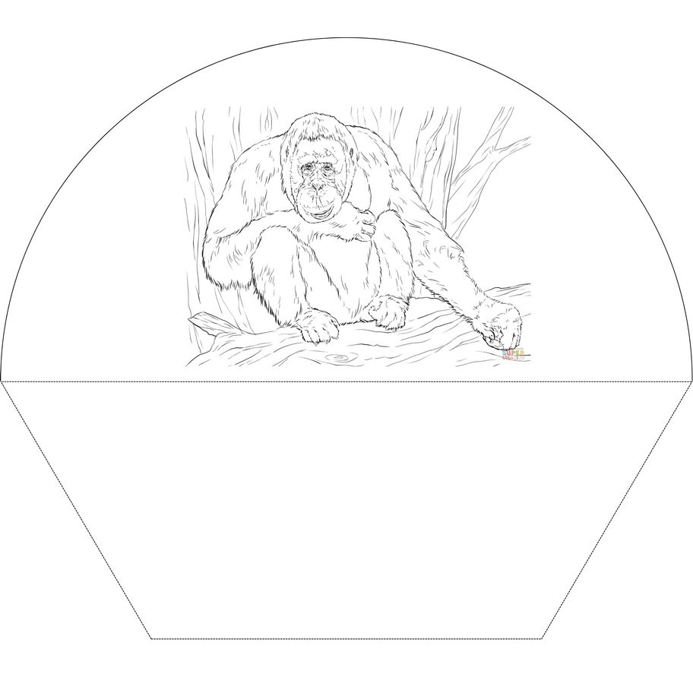
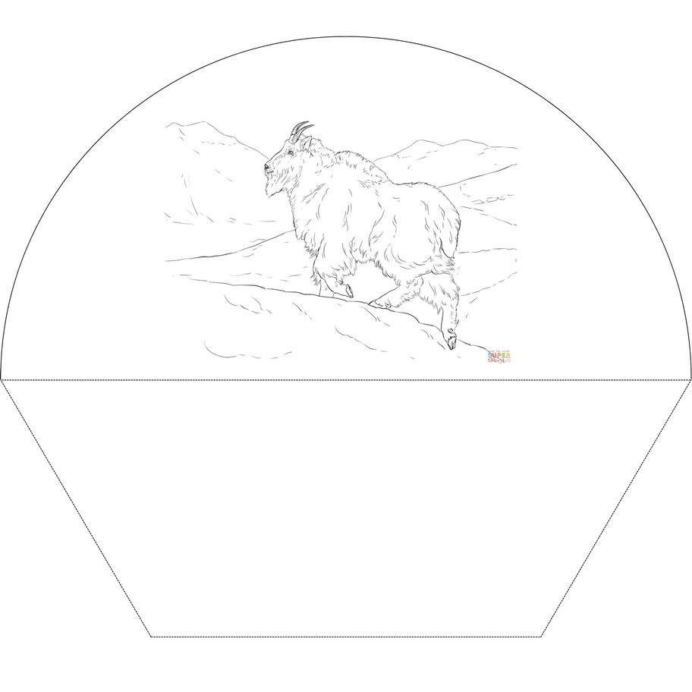
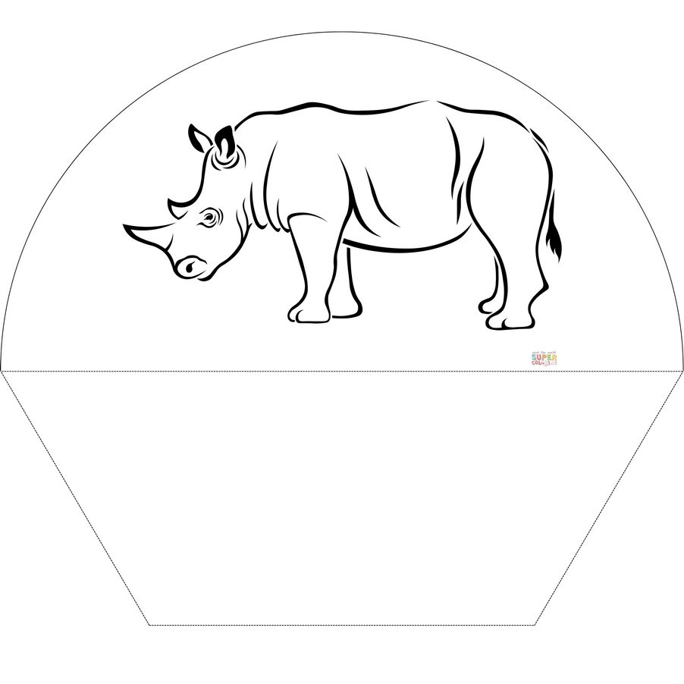
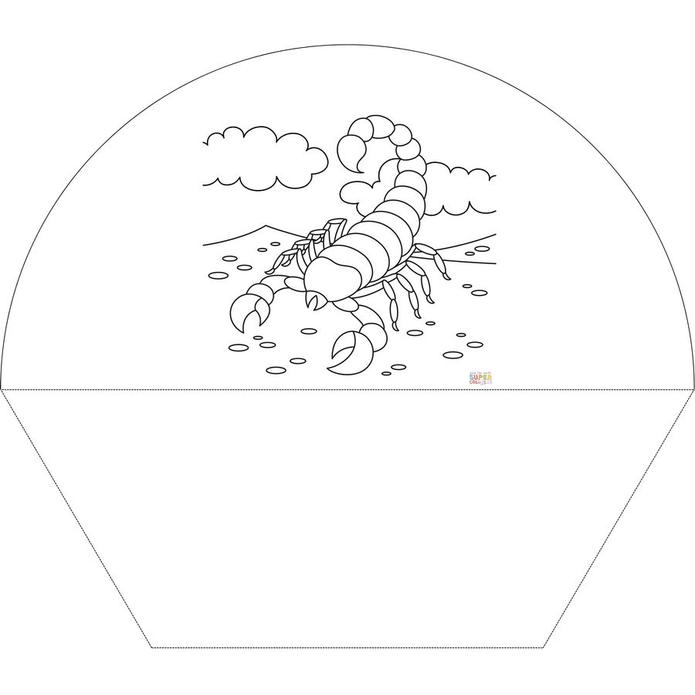
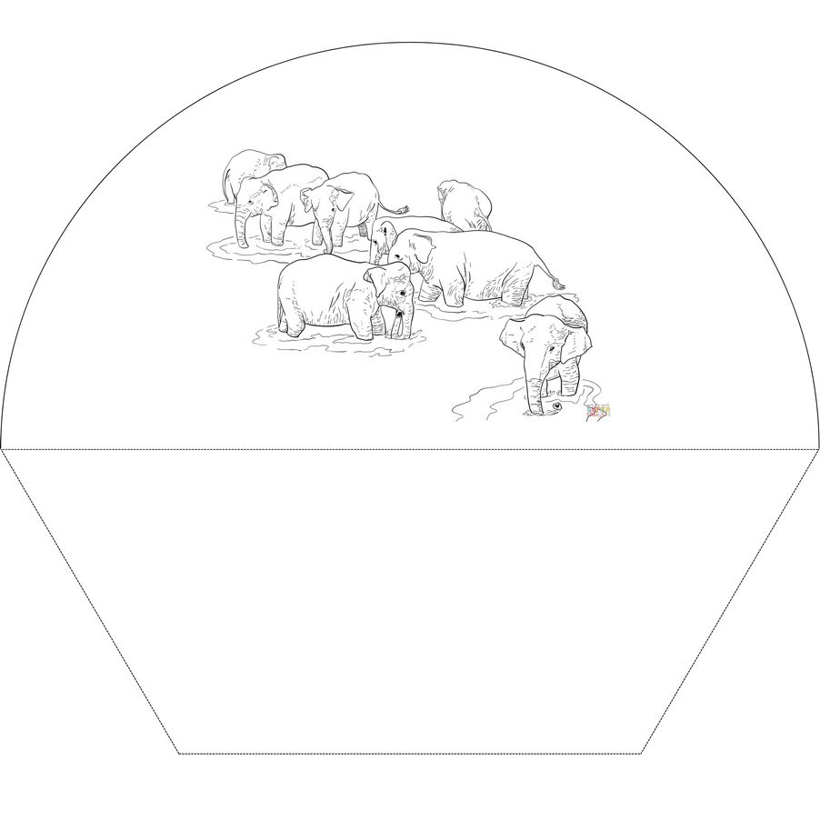
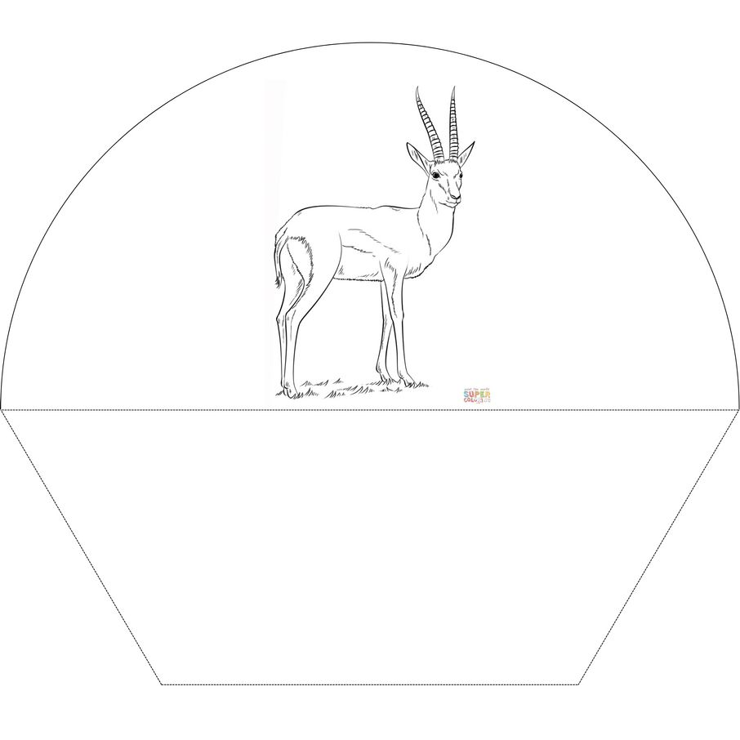
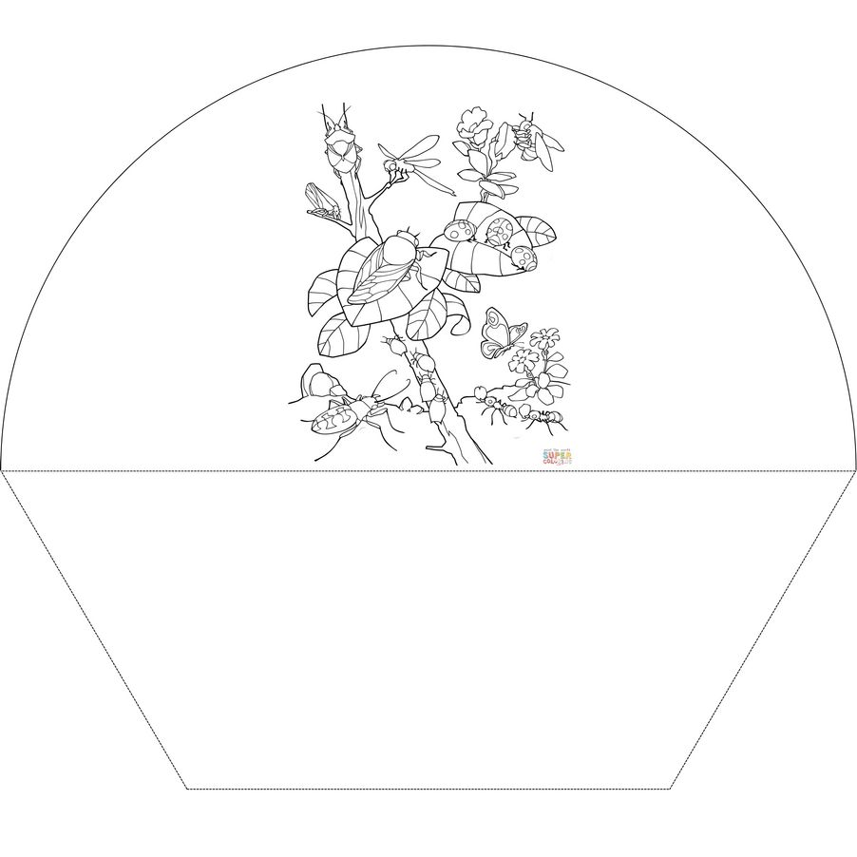
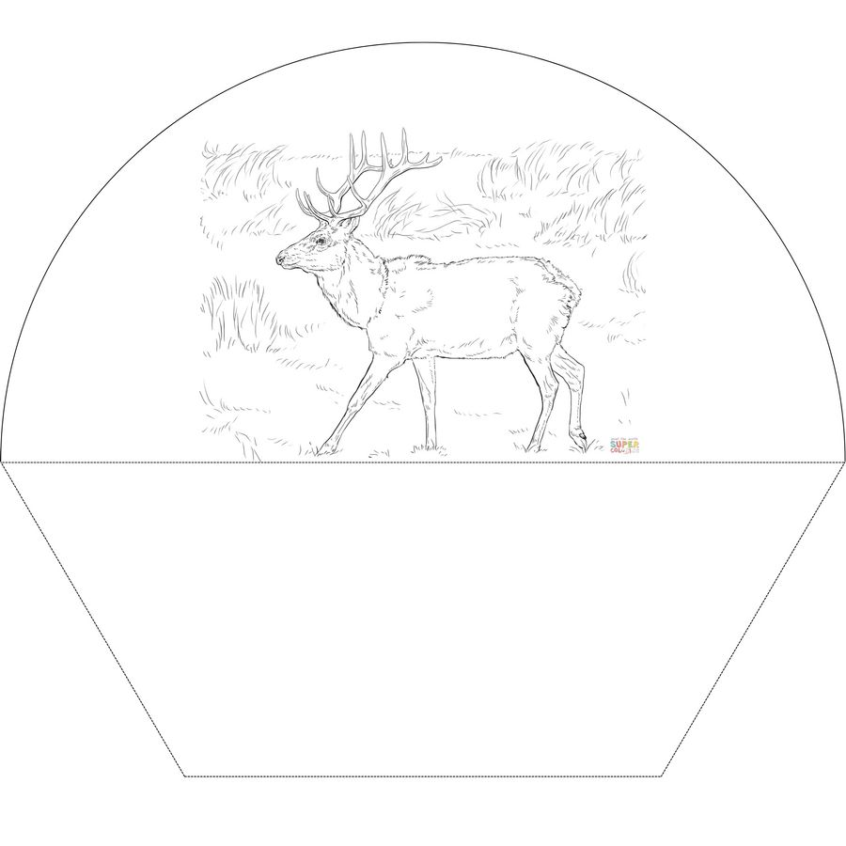

Flora
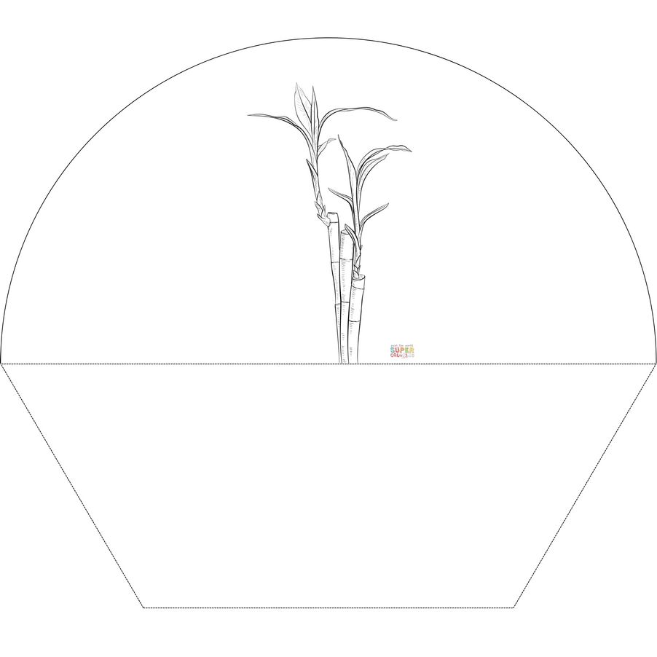
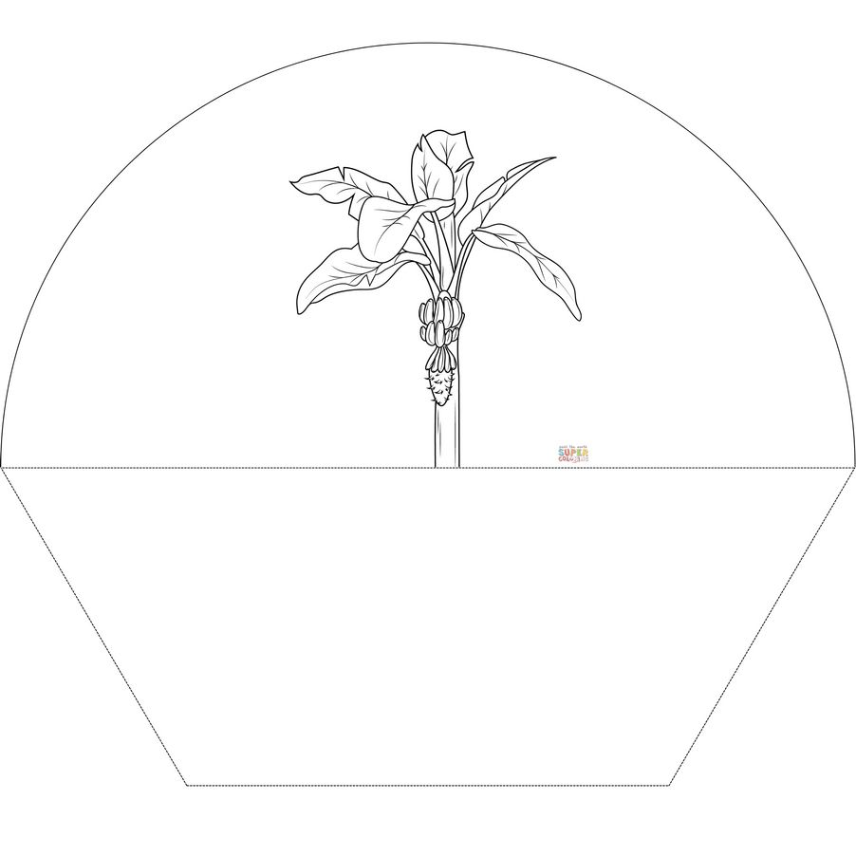
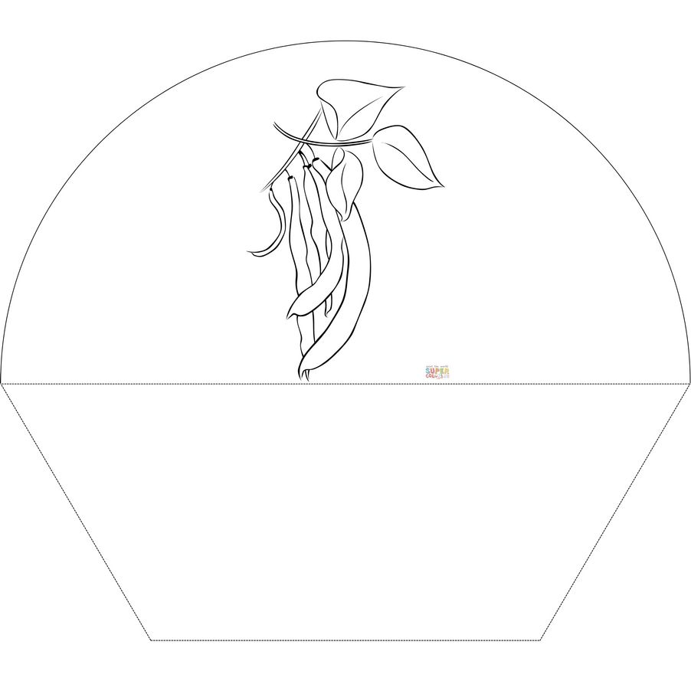
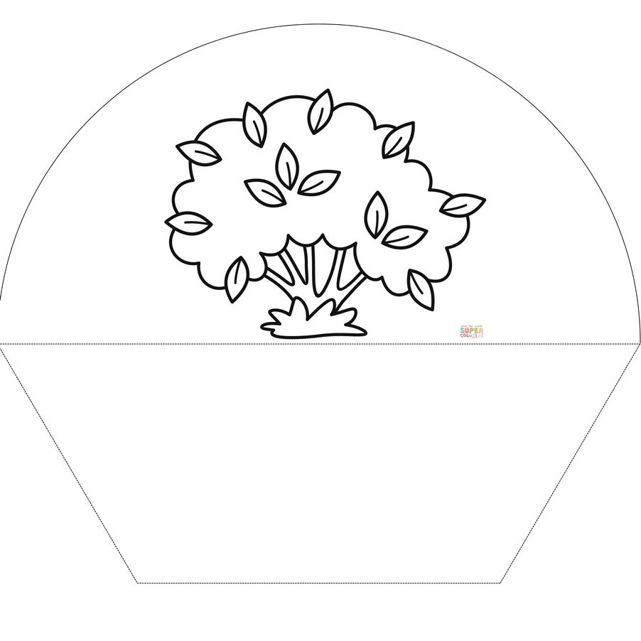
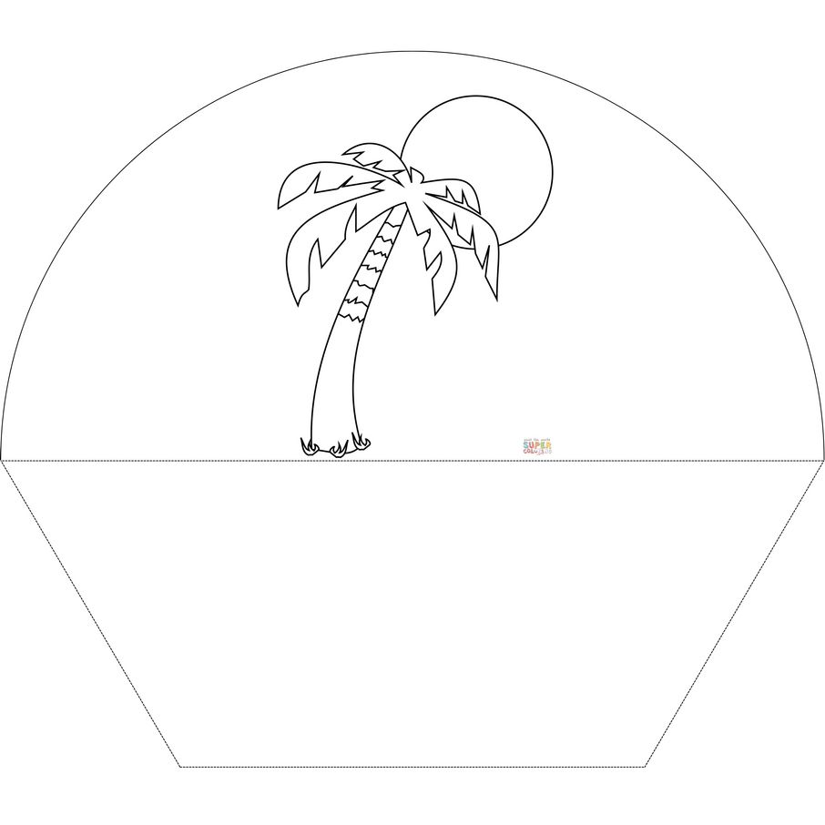
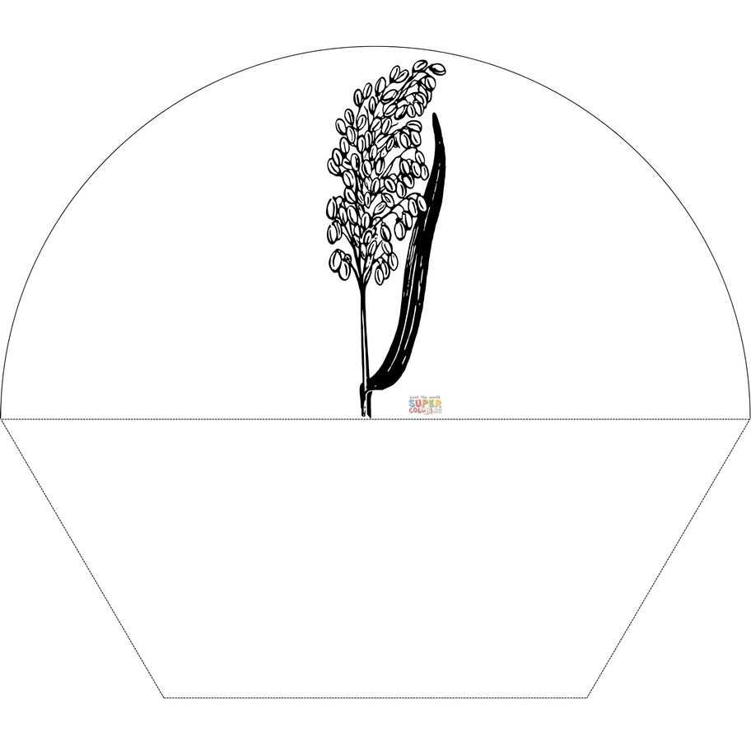
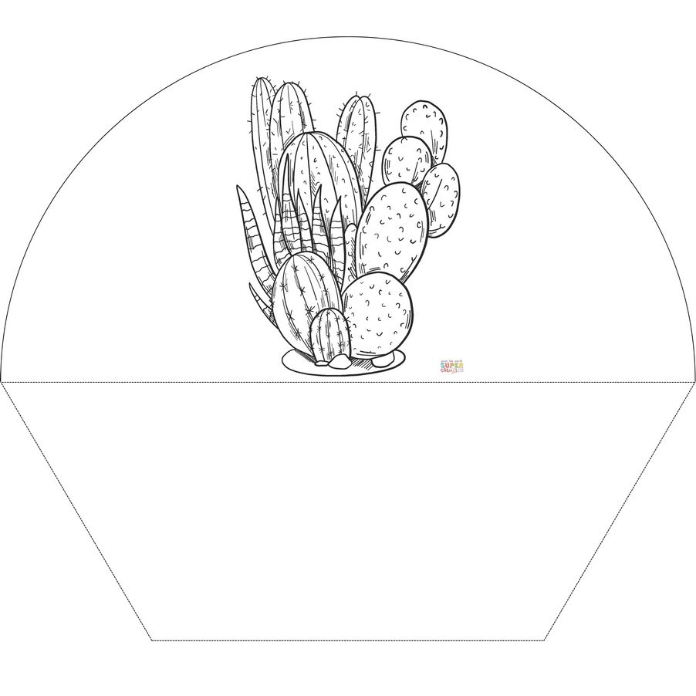
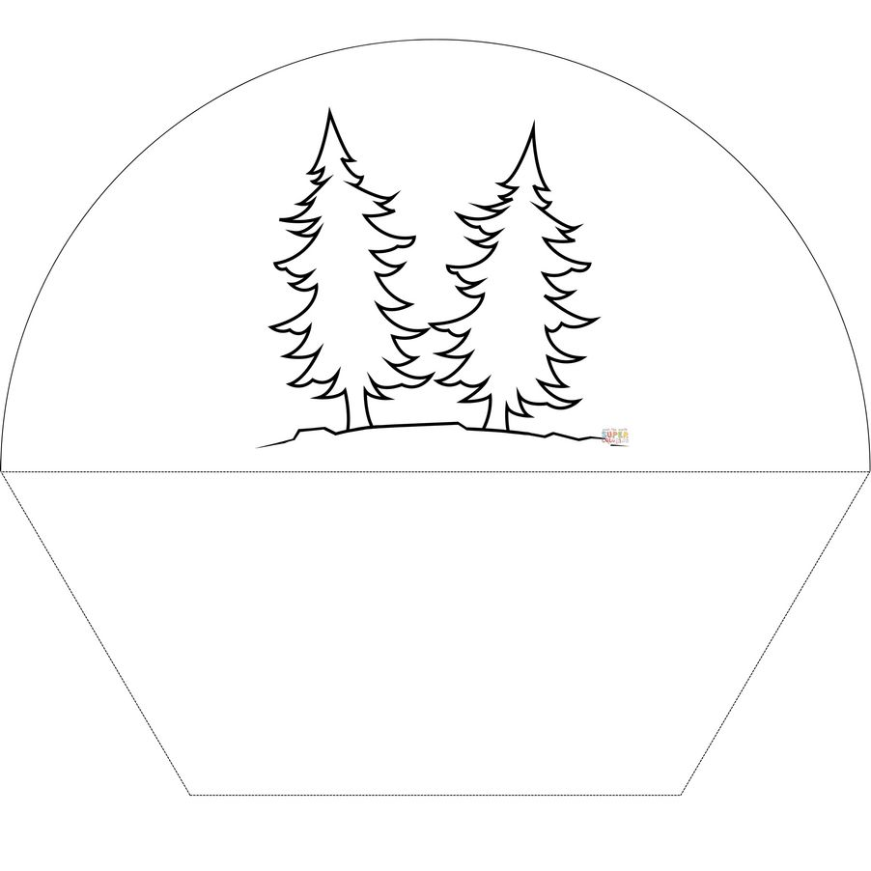
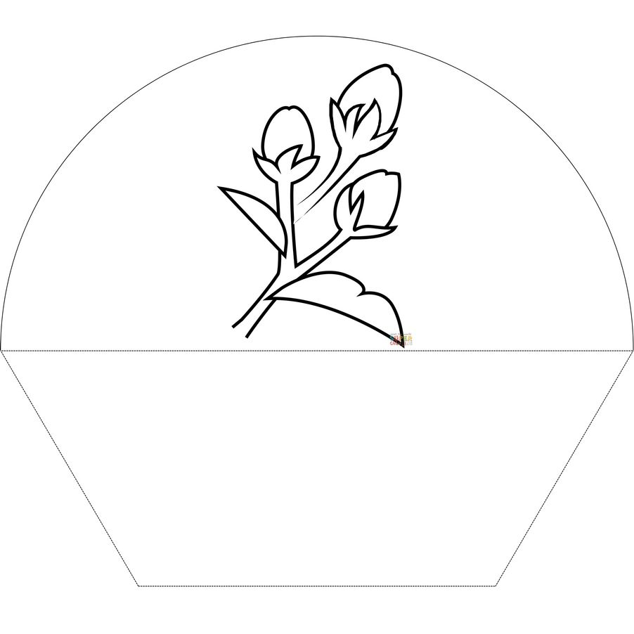
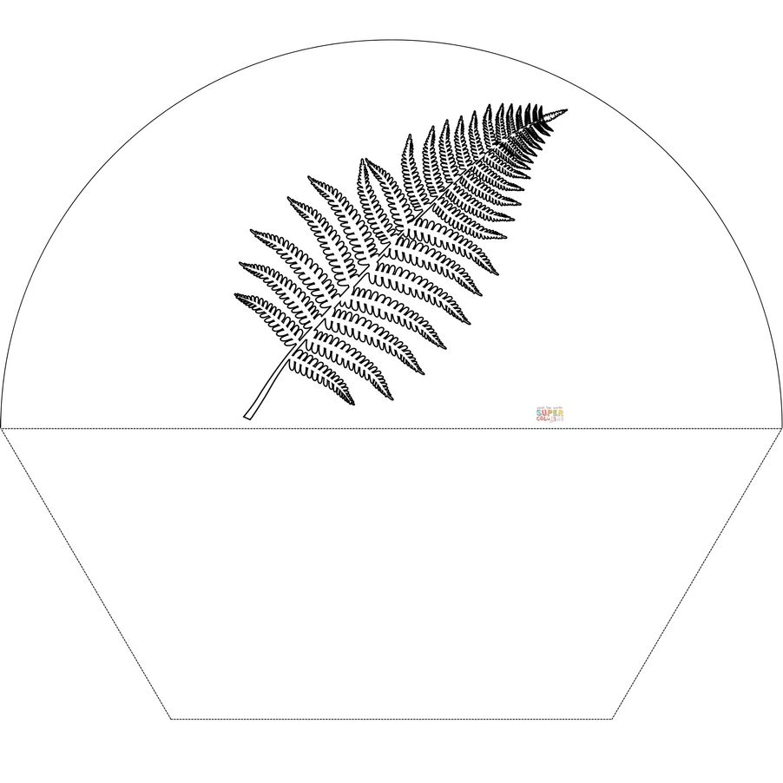
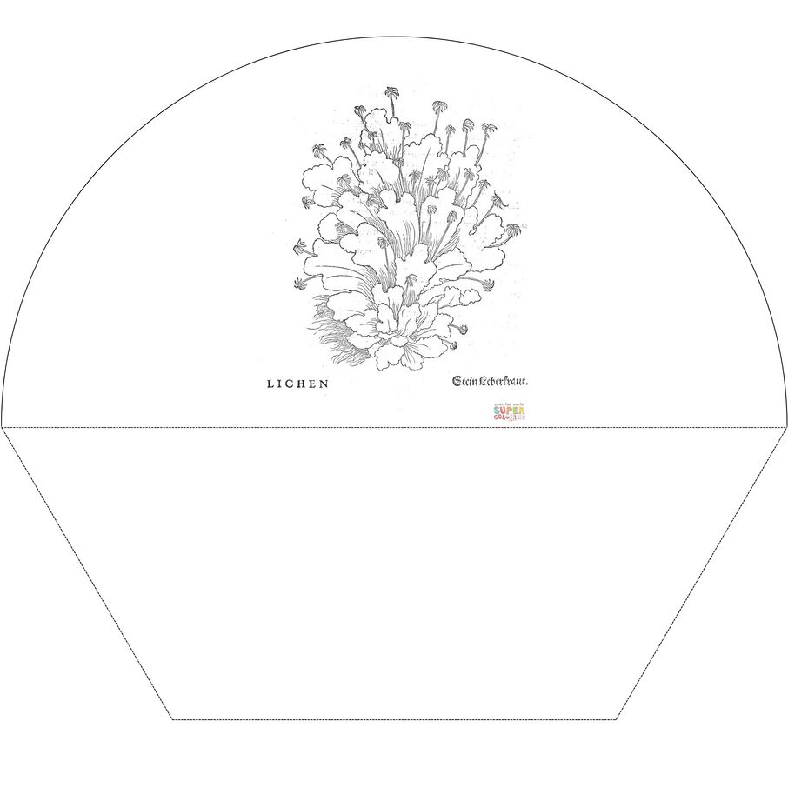
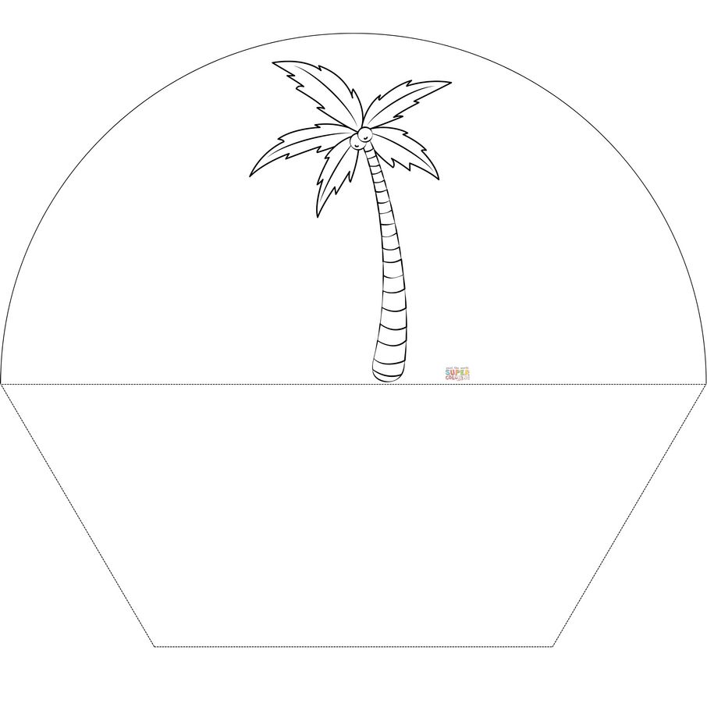
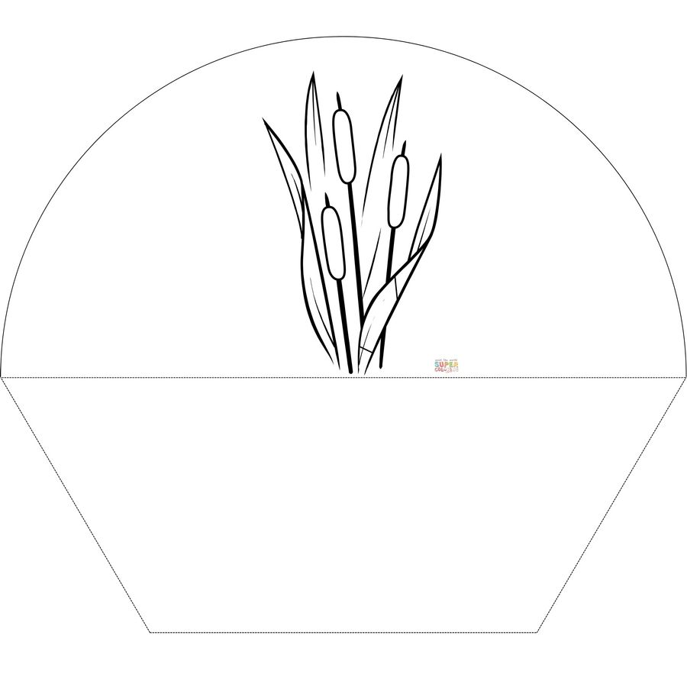

Medios de transporte
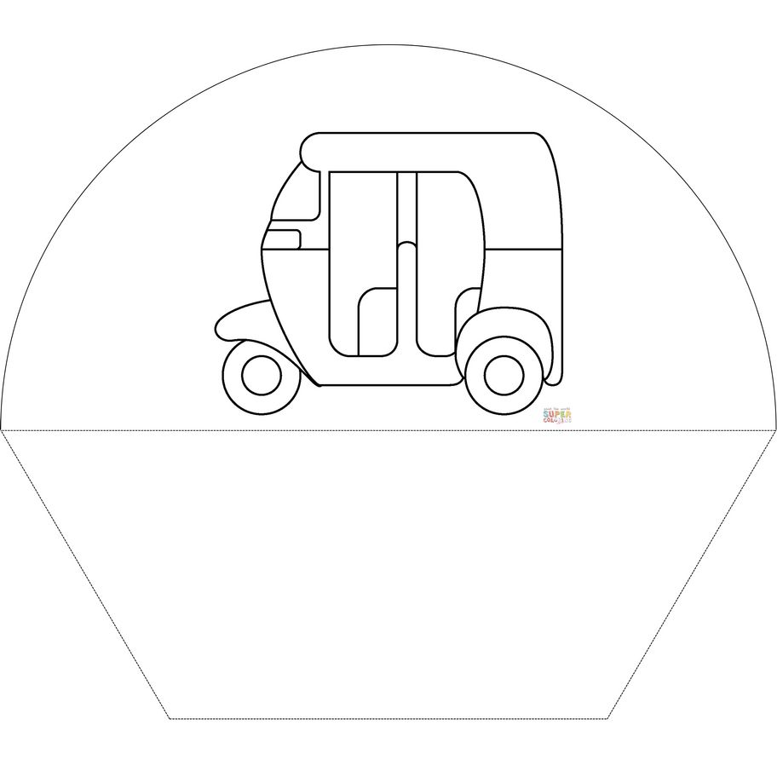
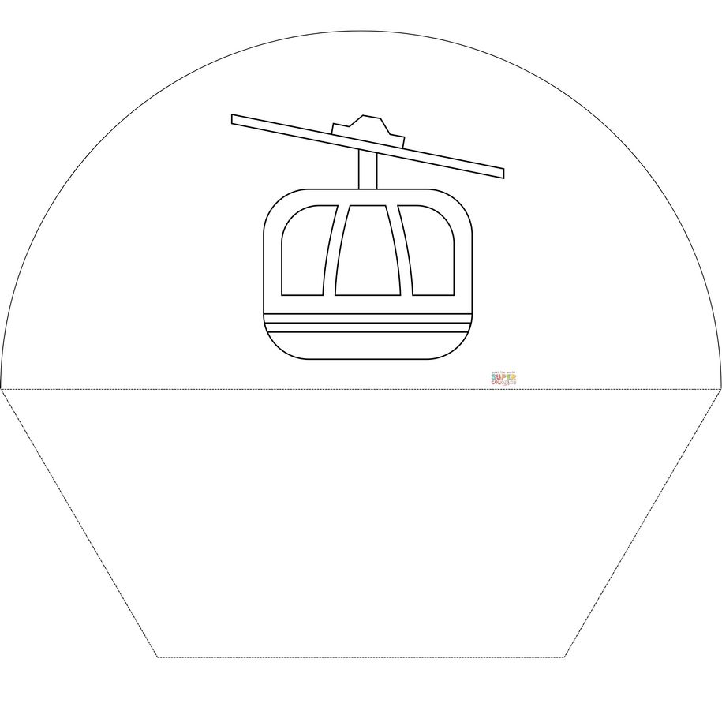
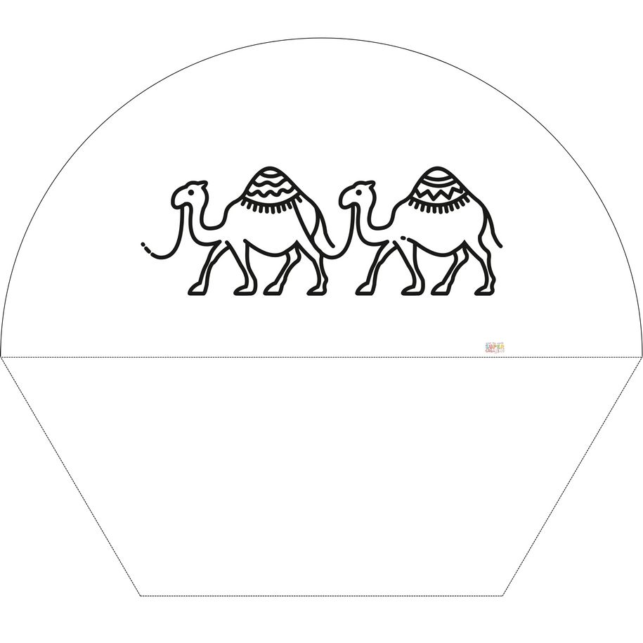
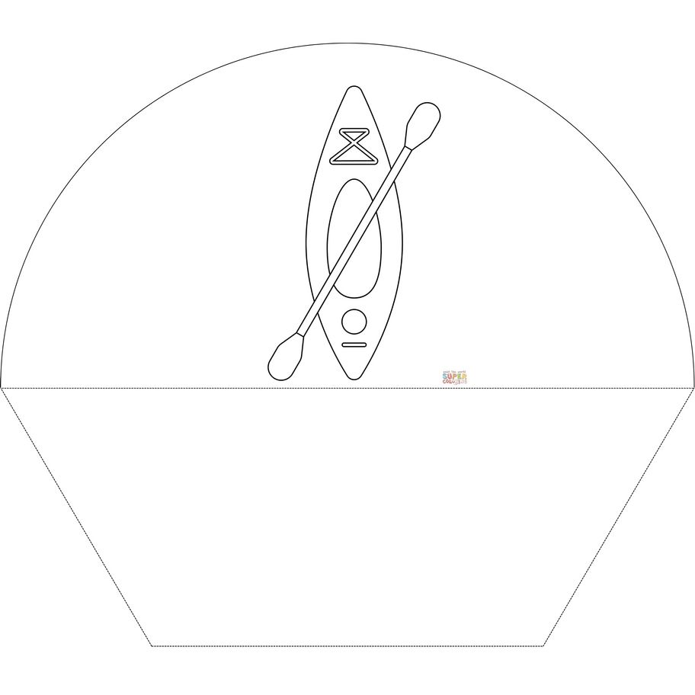
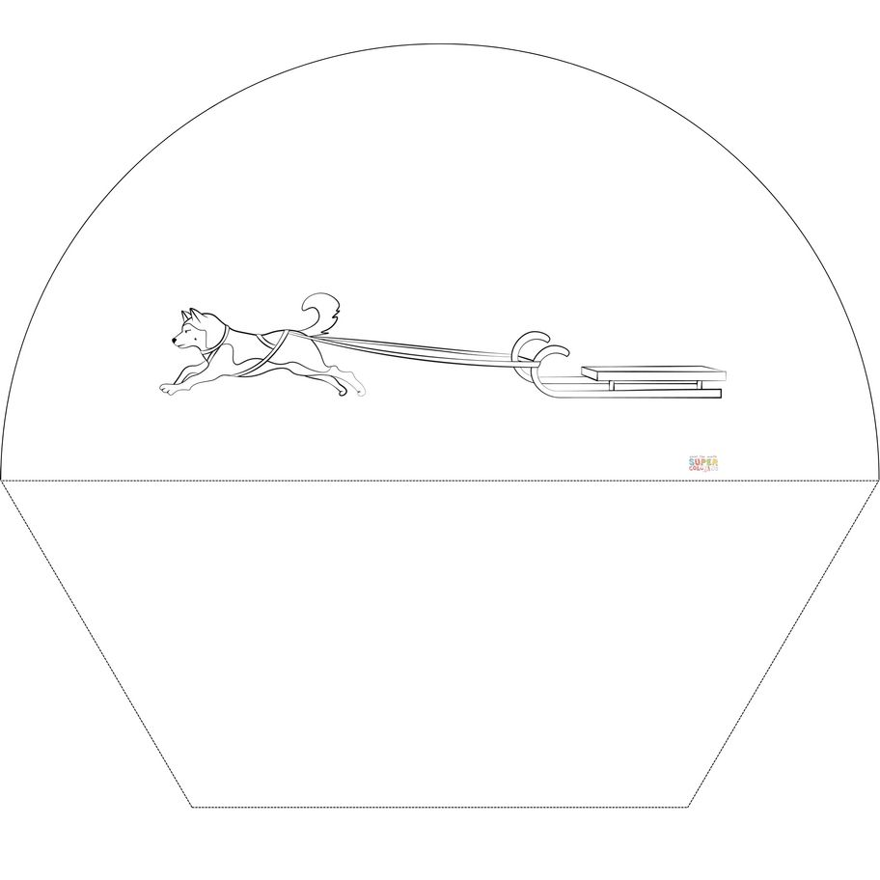

Atribución dos recursos incorporados ao documento
Recursos incorporados por orde de aparición e páxina:

Páxina 1: Lena London. Arctic Fox (https://www.supercoloring.com/coloring-pages/arctic-fox). Licenza CC SA (https://creativecommons.org/licenses/by-sa/4.0/)
Páxina 1: Autoría descoñecida. Artic Hares (https://www.supercoloring.com/coloring-pages/arctic-hares). Licenza CC BY-NC (https://creativecommons.org/licenses/by-nc/4.0/)
Páxina 1: Nata Silina. Gaviotín volando (https://www.supercoloring.com/es/dibujos-para-colorear/gaviotin-volando). Licenza CC BY 4.0 (https://creativecommons.org/licenses/by/4.0/)
Páxina 1: Lena London. Frailecillo del Atlántico (https://www.supercoloring.com/es/dibujos-para-colorear/frailecillo-del-atlantico-0). Licenza CC BY 4.0 (https://creativecommons.org/licenses/by/4.0/)

Páxina 2: Nata Silina. Bengal tiger (https://www.supercoloring.com/coloring-pages/bengal-tiger-0). Licenza CC BY-SA 4.0 (https://creativecommons.org/licenses/by-sa/4.0/)
Páxina 2: Lena London. Bird’s Nest (https://www.supercoloring.com/coloring-pages/birds-nest). Licenza CC BY-SA 4.0 (https://creativecommons.org/licenses/by-sa/4.0/)
Páxina 2: Lena London. Polar Bear walking (https://www.supercoloring.com/coloring-pages/polar-bear-walking). Licenza CC BY-SA 4.0 (https://creativecommons.org/licenses/by-sa/4.0/)
Páxina 2: Autoría descoñecida. Snowy Owl (https://www.supercoloring.com/coloring-pages/snowy-owl-0). Licenza CC BY-NC 4.0 (https://creativecommons.org/licenses/by-nc/4.0/)
Páxina 2: Lena London. Orca Saltando (https://www.supercoloring.com/es/dibujos-para-colorear/orca-saltando?tag=58322). Licenza CC BY 4.0 (https://creativecommons.org/licenses/by/4.0/)
Páxina 2: Lena London. Narval (https://www.supercoloring.com/es/dibujos-para-colorear/narval-0?tag=58322). Licenza CC BY 4.0 (https://creativecommons.org/licenses/by/4.0/)

Páxina 3: Gennadiy Lukaynenko. Brown Rat (https://www.supercoloring.com/coloring-pages/brown-rat). Licenza CC BY-NC 4.0 (https://creativecommons.org/licenses/by-nc/4.0/)
Páxina 3: SuperColoring. Camel (https://www.supercoloring.com/coloring-pages/camel-3). Licenza CC BY-NC 4.0 (https://creativecommons.org/licenses/by-nc/4.0/)
Páxina 3: Autoría descoñecida. Clouded Leopard (https://www.supercoloring.com/coloring-pages/clouded-leopard). Licenza CC BY-NC 4.0 (https://creativecommons.org/licenses/by-nc/4.0/)
Páxina 3: Supercoloring. Crocodile (https://www.supercoloring.com/coloring-pages/crocodile-6). Licenza CC BY-NC 4.0 (https://creativecommons.org/licenses/by-nc/4.0/)
Páxina 3: Autoría descoñecida. Flying Fishes Shoal (https://www.supercoloring.com/coloring-pages/flying-fishes-shoal). Licenza CC BY-NC 4.0 (https://creativecommons.org/licenses/by-nc/4.0/)
Páxina 3: Lena London. Flying Osprey (https://www.supercoloring.com/coloring-pages/flying-osprey). Licenza CC BY-SA 4.0 (https://creativecommons.org/licenses/by-sa/4.0/)

Páxina 4: Autoría descoñecida. Horned Viper (https://www.supercoloring.com/coloring-pages/horned-viper). Licenza CC BY-NC 4.0 (https://creativecommons.org/licenses/by-nc/4.0/)
Páxina 4: Autoría descoñecida. Pangolin (https://www.supercoloring.com/coloring-pages/pangolin-0). Licenza CC Public Domain (https://creativecommons.org/publicdomain/mark/1.0/)
Páxina 4: Ask A Biologist coloring pages. Poison Dart Frog (https://www.supercoloring.com/coloring-pages/poison-dart-frog-0). Licenza CC BY-SA 3.0 (https://creativecommons.org/licenses/by-sa/3.0/)
Páxina 4: Autoría descoñecida. Pond Skaters (https://www.supercoloring.com/coloring-pages/pond-skaters). Licenza CC BY-NC 4.0 (https://creativecommons.org/licenses/by-nc/4.0/)
Páxina 4: Gennadiy Lukaynenko. Realistic Bornean Orangutan (https://www.supercoloring.com/coloring-pages/realistic-bornean-orangutan). Licenza CC BY-NC 4.0 (https://creativecommons.org/licenses/by-nc/4.0/)
Páxina 4: Gennadiy Lukaynenko. Realistic Mountain Goat (https://www.supercoloring.com/coloring-pages/realistic-mountain-goat). Licenza CC BY-NC 4.0 (https://creativecommons.org/licenses/by-nc/4.0/)

Páxina 5: SuperColoring. Rhino (https://www.supercoloring.com/coloring-pages/rhino-0). Licenza CC BY-NC 4.0 (https://creativecommons.org/licenses/by-nc/4.0/)
Páxina 5: SuperColoring. Scorpion (https://www.supercoloring.com/coloring-pages/scorpion-7). Licenza CC BY-NC 4.0 (https://creativecommons.org/licenses/by-nc/4.0/)
Páxina 5: Danmaxx. Shri Lanka Elephants (https://www.supercoloring.com/coloring-pages/shri-lanka-elephants). Licenza CC BY-NC 4.0 (https://creativecommons.org/licenses/by-nc/4.0/)
Páxina 5: Lena London. Gacela Thomson (https://www.supercoloring.com/es/dibujos-para-colorear/gacela-thomson). Licenza CC BY 4.0 (https://creativecommons.org/licenses/by/4.0/)
Páxina 5: Ask A Biologist coloring pages. Insects (https://www.supercoloring.com/coloring-pages/insects-1). Licenza CC BY-SA 3.0 (https://creativecommons.org/licenses/by-sa/3.0/)
Páxina 5: Gennadiy Lukaynenko. Tule Elk Deer (https://www.supercoloring.com/coloring-pages/tule-elk-deer). Licenza CC BY-NC 4.0 (https://creativecommons.org/licenses/by-nc/4.0/)

Páxina 6: Autoría descoñecida. Planta de arroz de la vendimia (https://www.supercoloring.com/es/dibujos-para-colorear/planta-de-arroz-de-la-vendimia). Licenza CC Public Domain (https://creativecommons.org/publicdomain/mark/1.0/deed.es)
Páxina 6: Autoría descoñecida. Tropical Island (https://www.supercoloring.com/coloring-pages/tropical-island). Licenza CC Public Domain (https://creativecommons.org/publicdomain/mark/1.0/
Páxina 6: Lena London. Planta de Bambú (https://www.supercoloring.com/es/dibujos-para-colorear/planta-de-bambu). Licenza CC BY 4.0 (https://creativecommons.org/licenses/by/4.0/)
Páxina 6: PArtsashina. Banana Plant with Bananas (https://www.supercoloring.com/coloring-pages/banana-plant-with-bananas). Licenza CC BY-SA 4.0 (https://creativecommons.org/licenses/by-sa/4.0/)
Páxina 6: Autoría descoñecida. Frijoles (https://www.supercoloring.com/es/dibujos-para-colorear/frijoles). Licenza CC Public Domain (https://creativecommons.org/publicdomain/mark/1.0/deed.es)
Páxina 6: SuperColoring. Bush (https://www.supercoloring.com/coloring-pages/bush). Licenza CC BY-NC 4.0 (https://creativecommons.org/licenses/by-nc/4.0/)

Páxina 7: SuperColoring. Cactus (https://www.supercoloring.com/es/dibujos-para-colorear/cactus-13). Licenza CC BY 4.0 (https://creativecommons.org/licenses/by/4.0/)
Páxina 7: Ask A Biologist coloring pages. Conifer Trees (https://www.supercoloring.com/coloring-pages/conifer-trees). Licenza CC BY-SA 3.0 (https://creativecommons.org/licenses/by-sa/3.0/)
Páxina 7: Ask A Biologist coloring pages . Cotton Flower (https://www.supercoloring.com/coloring-pages/cotton-flower-0). Licenza CC BY-SA 3.0 (https://creativecommons.org/licenses/by-sa/3.0/)
Páxina 7: SuperColoring. Helecho (https://www.supercoloring.com/es/dibujos-para-colorear/helecho-0). Licenza CC BY-NC 4.0 (https://creativecommons.org/licenses/by-nc/4.0/deed.es)
Páxina 7: Autoría descoñecida. Lichen (https://www.supercoloring.com/coloring-pages/lichen). Licenza CC Public Domain (https://creativecommons.org/publicdomain/mark/1.0/)
Páxina 7: Lena London. Palm Tree (https://www.supercoloring.com/coloring-pages/palm-tree-11). Licenza CC BY-NC 4.0 (https://creativecommons.org/licenses/by-nc/4.0/)

Páxina 8: Autoría descoñecida. Reeds (https://www.supercoloring.com/coloring-pages/reeds). Licenza CC BY-SA 3.0 (https://creativecommons.org/licenses/by-sa/3.0/)

Páxina 9: Twitter / Supercoloring.com. Auto Rickshaw (https://www.supercoloring.com/coloring-pages/auto-rickshaw-emoji-0). Licenza CC BY 4.0 (https://creativecommons.org/licenses/by/4.0/)
Páxina 9: JoyPixels. Teleférico (https://www.supercoloring.com/es/dibujos-para-colorear/teleferico). Licenza CC BY 4.0 (https://creativecommons.org/licenses/by/4.0/)
Páxina 9: SuperColoring. Camel Caravan (https://www.supercoloring.com/coloring-pages/camel-caravan-0). Licenza CC BY-NC 4.0 (https://creativecommons.org/licenses/by-nc/4.0/)
Páxina 9: SuperColoring. Kayak (https://www.supercoloring.com/coloring-pages/kayak-3). Licenza CC BY-NC 4.0 (https://creativecommons.org/licenses/by-nc/4.0/)
Páxina 9: SuperColoring. Sled Dog (https://www.supercoloring.com/es/node/2509210?tag=65130). Licenza CC BY-NC 4.0 (https://creativecommons.org/licenses/by-nc/4.0/deed.es)


“Elementos do minimundo”, do proxecto cREAgal, publícase coa Licenza Creative Commons Recoñecemento Non-comercial Compartir igual 4.0

